Topic | Graph Traversal
Learning Objectives | The students can understand and apply the graph traversal algorithm/  The students can represent social relation using graph.
Problem 1  [10 points] | Following defined friend relation ‘-‘ is transitive and symmetric. We can infer additional friend relations from below given friend relations.  Mike-Luke, George-Greg, Luke-Alice, Allen-Greg, George-Dane, Luke-George  For example, we can infer George-Allen relationship from George-Greg, Allen-Greg and George-Greg, Greg-Allen.  1) Which graph is better directed graph or undirected graph to reflect characteristic of relation ‘-‘? Show why your selection is reasonable.  Undirected graph is better to reflect characteristic of relation ‘-‘. Because we don’t need to know the node’s order.  2) When the given relations ‘-‘ are represented as a graph, determine whether it is connected graph or not. Show why your selection is reasonable.  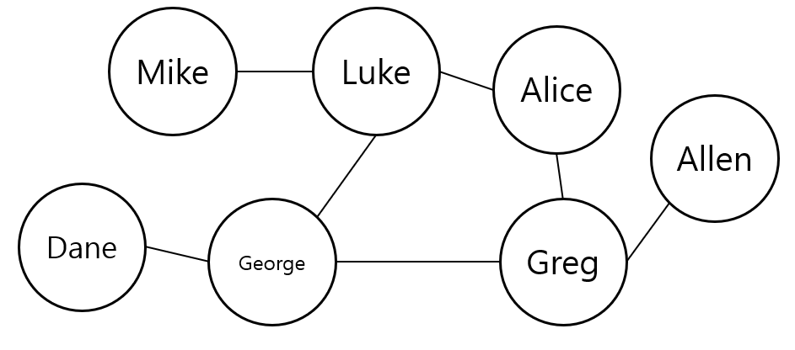  We draw this graph, every node has a path to every node. So it is connected graph.
Problem 2  [20 points] | 1) Draw at least two possible trees that we can get by performing the depth first search of the following graph from vertex D.  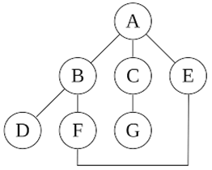  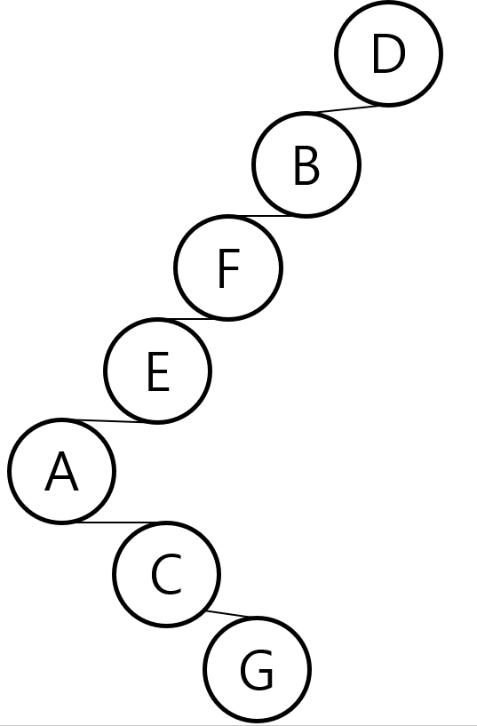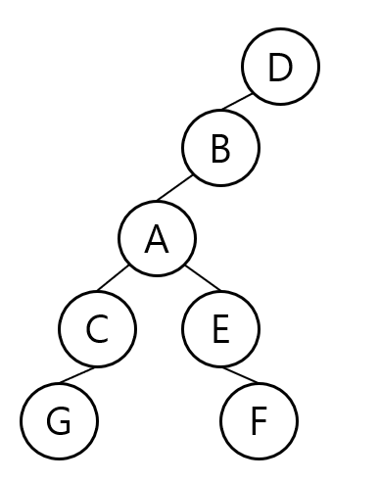  2) Draw the corresponding graph when the adjacency list is given like the following.  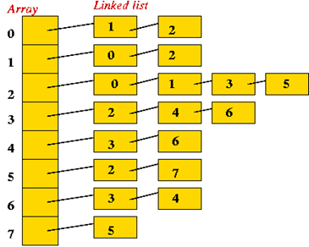  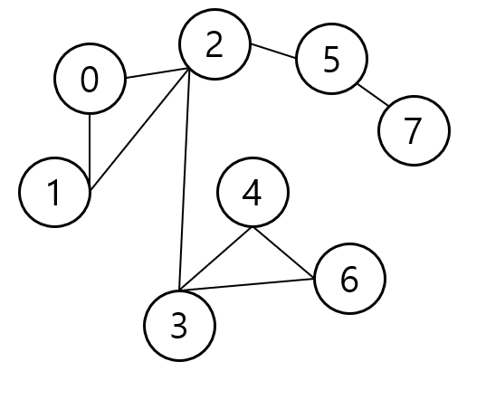
Problem 3  [70points] | Develop your program that print out all nodes which have a relationship with specific node and analysis friend relations  [Functional requirements]  - A user can select from ‘insert’, ‘search’, ‘analyze’ and ‘quit’.  - When the user select ‘insert’, the program shows ‘Input all the members’ and requests the number of members and the names of members. For example, if we insert the friend relations given in problem 1, the input will be as follows;  “Mike Luke George Greg Alice Allen Dane”  After the insertion of all members is finished, the user input relations in the form of ‘name’-‘name’ in alternate lines. To finish the input, the user will input ‘.’ in a blank line. A name is case-insensitive.  - When the user selects ‘search’, the program requests a name. Then the program prints all the names who are connected with the input name.  - When the user select ‘Analyze’, the program prints the degree of each name and show the names of articulation points. The analysis should be executed right after the input of friend relations is finished. When the user select ‘Analyze’, the program prints stored analysis results.  - When the user select ‘Quit’, the program prints a farewell message and terminates.  1) Define new data structure for node based on below definition when relation ‘-‘ is represented as a graph. Show why your definition is reasonable.  typedef struct node *nodePointer;  typedef struct node {  int vertex;  nodePointer link;  };  #define MAX_NAME 10  #define MAX_VER 10  typedef struct node *nodePointer;  typedef struct node {  int vertex;  char name[MAX_NAME];  nodePointer link;  } node;  typedef struct graphType {  int n;  nodePointer adjList[MAX_VER];  }graphType;  We need a name in vertex. And to use adjacency list, so make graphType struct.  2) Describe a flow of overall program operation and design a necessary data structures, functions and etc.  -Data structures  #define MAX_NAME 10  #define MAX_VER 10  typedef struct node *nodePointer;  typedef struct node {  int vertex;  char name[MAX_NAME];  nodePointer link;  } node;  typedef struct graphType {  int n;  nodePointer adjList[MAX_VER];  }graphType;  -Functions  void createGraph(graphType* g);  //Create new graph  void insertVertex(graphType* g, char name[]);  //request number of members -> names of members  //while (number of members) { make a new node }  void insertEdge(graphType *g, char n1[], char n2[]);  //request n1-n2  //while (){ make a edge by n1 and n2 }  //if(n1 or n2 == '.') break;  //if(searchGraph(n1) or searchGraph(n2) == null) break;  void searchGraph(graphType* g, char name[]);  //request name  //find name using adjList  //print all connected node  void analyzeGraph(graphType* g);  //while(adjList is NULL){ use searchGraph }  3) Implement a module which extracts ABC, def from the input friend relation string “ABC-def”. You can use C string library.  int parseString(char *inputString, char *outputName1, char *outputName2)  {  char *ptr = strtok(inputString, "-");  outputName1 = ptr;  ptr = strtok(NULL, NULL);  outputName2 = ptr;  }  4) Describe an algorithm of insertList() module that registers input friend relations to adjList[]. The insertList() uses the extracted names as input parameters from the input friend relation using module designed in 2)  void insertList(char *name1, char *name2){  graphType g;  for (int i = 0; i < MAX_VER; i++) {  for (int j = 0; j < MAX_VER; j++) {  if (g.adjList[i]->name == name1) {  if (g.adjList[j]->name == name2) {  g.adjList[i]->link = g.adjList[j];  g.adjList[j]->link = g.adjList[i];  }  }  }  }  }  5) When we develop a function that analysis articulation point, we can make use of the following module. Suggest how to modify the module.  void bicon (int u, int v)  {  nodePointer ptr;  int w; int x; int y;  dfn[u] = low[u] = num++;  for (ptr = graph[u]; ptr; ptr = ptr->link) {  w = ptr->vertex;  if(v != w && dfn[w] < dfn[u]) push(u, w);  if(dfn[w] < 0) {  bicon(w, u);  low[u] = MIN2(low[u], low[w]);  if(low[w] >= dfn[u]) {  printf("New biconnected component: ");  do {  pop(&x,&y);printf(" <%d,%d>",x,y);  } while(!((x == u) && (y == w)));  printf(" \n");} } else if (w != v) low[u] = MIN2(low[u], dfn[w]);} }  6) Complete a program which satisfies described functional requirements based on designed algorithms from 1) to 5). Test your program with friend-relations given in problem 1.  in my zip file.

